Equality Impact Assessment
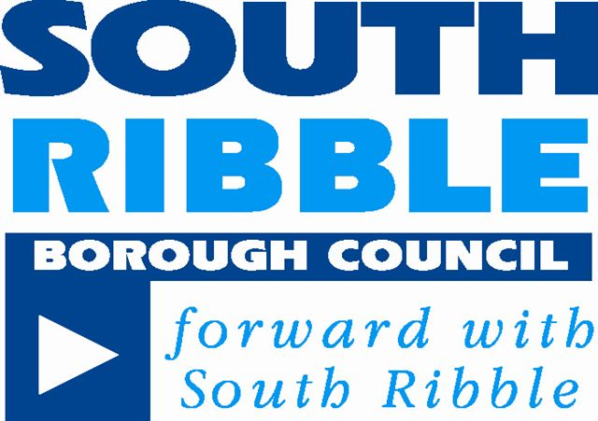

Introduction

An Equality Impact Assessment (EIA) is required to ensure that equality is placed at the centre of policy development and review, as well as service delivery. The purpose of this EIA is to systematically analyse the likely impact of a service, policy or proposals on different community groups, and how the needs of such groups have been taken into account in developing those proposals.

The EIA can anticipate and recommend ways to avoid any discriminatory or negative consequences for a particular group, on the grounds of any protected characteristic. It provides the opportunity to demonstrate the potential benefits for equality target groups arising from a proposed policy or project.

The need for an EIA stems from the general duty placed on public authorities to eliminate unlawful discrimination in carrying out functions, and promote equality of opportunity. This is outlined in the Equality Act 2010, with specific public sector duties in place from April 2011.

1. Name of Policy or Service (existing or proposed)
Procedure for ensuring roadworthiness of licensed vehicles which have been subject to modification

2. Responsible Manager
Peter Haywood

3. Date EIA completed | Review date
21 April 2017 | Revisited on 27 February 2018
4. Description and aims of policy / service (including relevance to equalities)
South Ribble Borough Council has a responsibility to ensure that all vehicles operating as hackney carriage and private hire vehicles are fit for purpose. This is particularly important for vehicles which have been adapted, converted or modified to carry passengers who use wheelchairs or who have specialised needs.
South Ribble is home to one of the largest number of vehicles which have been self-converted from vans to carry wheelchair passengers. Whilst the current roadworthiness checks ensure that a vehicle is mechanically sound, they do not extend to checking that the modifications have been carried out to the required standard.
This policy will apply to all vehicles that have been converted, modified or adapted from the original manufacturer’s specification since first registration and is intended to provide additional safeguards to ensure that the conversion, modification or adaptation has been completed to the required standard and remains in such state for the period that the vehicle is licensed by this Authority.
This policy will not apply to any vehicle including wheelchair accessible vehicles that are produced for licensing that have not been converted, modified or adapted since its initial registration.
5. Who are the stakeholders?
Council officers

All Councillors including in particular the members of the Council’s General Licensing Committee

All those who have or wish to have (i) Hackney Carriage drivers or vehicle licences, or (ii) Private Hire operator and driver licences

Local companies which modify vehicles on a commercial basis

Various teams within the Council including Legal Services and Environmental Health (incorporating Licensing)

6. What outcomes do we want to achieve?
The introduction of safe standards and a regular testing regime which will ensure that any modifications to licensed vehicles are carried out in a roadworthy manner.

7. How will performance be measured?
Number of modified vehicles subject to the testing regime and which are confirmed to be roadworthy once the modification has been carried out.

Number of modified vehicles subject to the testing regime and which are confirmed to be roadworthy once the modification has been carried out.

8. Brief summary of research and background data
Given that the Borough has a major modifier of vehicles operating within its boundaries, there are a large number of modified vehicles operating in the Borough. These are frequently used to transport children to and from Special Educational facilities across the Borough and beyond.

9. Methods and outcome of consultation
Since the issue was raised with members in March 2017, two formal periods of consultation have taken place as well as an ad hoc meeting with key stakeholders. The Taxi Trade Forum has also been updated on this initiative on a regular basis. As a result, several iterations of the draft testing specification for modified vehicles have been produced and members are now asked to consider whether to recommend adopting the proposed approach.

10. Results of initial screening
The following questions have been considered in order to evaluate the various equality groups:-

Age – Is there any concern that these proposals could cause differential impact on the grounds of age?

Many modified vehicles are used to transport children with special educational needs to school and back. These children are vulnerable and it is imperative to ensure their safety as well as that of other road users.

Disability – Is there any concern that these proposals could cause differential impact on the grounds of disability? Disability is recognised under the Equality Act as ‘a physical or mental impairment which has a substantial and long term effect on a person’s ability to carry out normal day to day activities.’

As stated above, by definition many of the users of modified vehicles have disabilities; the purpose of this proposed Policy is to ensure their safety and that of other road users.

Gender Reassignment – Is there any concern that these proposals could cause differential impact on the grounds of gender reassignment? The Equality Act recognises this where a person is proposing to undergo, is undergoing, or has undergone a process (or part of a process) for changing sex.

No concern.

Marriage / Civil Partnership – Is there any concern that these proposals could cause differential impact on the grounds of marriage or civil partnership? Under the Equality Act, no such protection exists for single or unmarried people.

No concern.

Pregnancy / Maternity – Is there any concern that these proposals could cause differential impact on the grounds of pregnancy or maternity?

No concern.

Race – Is there any concern that these proposals could cause differential impact on the grounds of race? Race is recognised under the Equality Act as a person’s skin colour, nationality or ethnic origin.

No concern.

Sex – Is there any concern that these proposals could cause differential impact on the grounds of gender? Including men, women and transgender people.

No concern.

Sexual Orientation – Is there any concern that these proposals could cause differential impact on the grounds of sexuality? Including heterosexual, gay, lesbian and bisexual people.

No concern.

Religion or belief – Is there any concern that these proposals could cause differential impact on the grounds of religion or faith? All faiths recognised in the European Convention of Human Rights are included.

No concern.

A commentary has been provided for each policy where appropriate – see Appendix A

11. Links with the Council’s Safeguarding Policy (please outline any implications and actions that need to be taken)
Safeguarding relating to users of licensed hackney carriage / private hire vehicles (whether disabled or not) is a prime concern for the Licensing Authority.

12. Decisions and / or recommendations (including supporting rationale)
Members are asked to consider whether they wish to ask officers to explore implementation of the proposed policy.

13. Is an Equality Action Plan required?
No – see commentary in Appendix A below

Appendix A – Results of initial screening

Policy / service | Protected Characteristics |  |  |  |  |  |  |  |  | Commentary
 | Age | Disability | Gender reassignment | Marriage / civil p’ship | Pregnancy / maternity | Race | Religion or belief | Sex | Sexual Orientation
Activation of elements of section 165 and 167 of the Equalities Act 2010 relating to wheelchair users –implications for Licensing Authorities | + | + | O | O | O | O | O | O | O | Minimal impact on the Equalities agenda.

Symbol | Impact
+ | Positive
O | Neutral / Negligible
- | Negative
P | Potential issue

